**

**Project Manager: Luis Ruiz  
Architecture Lead: Ian Davies  
Solutions Lead: Parsa Arfai  
Quality Assurance Lead: Marcos Vallejos  
Business Lead: Mercy Jalango**

Contents

Executive Summary 3

Defining Business Objectives 3

Project charter for the development of ASSETRUST 5

NPV 6

ROI 6

User Stories 7

Schedule 9

Budget Plan 10

Human Resources Plan 11

**Roles and Responsibilities** 11

**Project Organizational Charts** 12

**Staffing Management** 13

**Training:** 14

Quality Management Plan 14

**Quality Standards** 14

**Reference Material** 15

**Quality Objectives** 15

**Quality Roles and Responsibilities** 15

**Quality Planning** 16

**Quality Control Approach** 17

**Quality Assurance** 18

**Quality Audits** 18

Risk Management Plan 18

**Methodology** 19

**Roles and Responsibilities** 19

**Budget and Schedule** 19

**Risk Categories** 20

**Risk Probability and Impact** 21

**Tracking** 21

**Risk Documentation** 21

Project Closeout 23

Conclusion 25

​REFERENCES 26

# Executive Summary

When it comes to cost, data center outages can cause millions of dollars in losses. Breaking down causes outages, 22% consist of human error which also result in cyber-attacks, weather-related outages make up 10% while heating and cooling problems account for 11%.  Data center outages impact employees, management, and can sometimes be attributed to a cyber-attack which could be costly.  A key approach to the financial losses in relevance to data centers is identification, prediction, and resolution of problems regarding outages beforehand. A critical component of data center profitability and efficiency is asset management. Asset management requires a platform to manage, monitor, measure, and control resources. This results in interoperability and interconnectivity which will ensure that the millions of dollars of lost revenues within the data center market are averted.  **(Malone 2021)**ASSETRUST management software is designed to optimize resource allocation, management, and optimization through AI and provide asset visibility, security, resource management, connectivity, incident analytics and risk management. **(Zenlayer 2018).**

# Defining Business Objectives

When it comes to the matter of asset management, especially in the field of IT (Information Technology), there are a myriad of different solutions available to address the needs of managers and users alike. When it comes to server management, software such as NinjaOne provides tools to monitor and manage all network devices, workstations, laptops, Windows servers, etc. Network management, while like the management of servers, requires a distinct set of capabilities such as those provided by Auvik. This includes being able to capture data from every device on the network and giving visibility on the connectivity of every device. If managing the procurement and disposal of assets is needed, IT asset management software such as AssetExplorer that supports discovery and tracking of both physical and software assets. Then there are solutions such as Spiceworks IT that allows for the categorization of assets on the network, and software such as Samange that provides risk detection capabilities on top of asset management.

At their basis, those tools are inadequate to solve the key issues that data centers are having, and that is that while they great functionality by themselves, they are spread out throughout multiple platforms leading to ineffectiveness. ASSETRUST will take advantage of the market combining the most useful traits of various other platforms who try to occupy the same role and further boost their effectiveness through our Sev-1 identification AI. Unlike other similar platforms in the same sphere, ASSETRUST will provide a comprehensive overview of all aspects of asset management. This creates a valuable resource to those in charge of asset management and procurement for large data centers, increasing effectiveness and productivity. In this sense, ASSETRUST singularly takes the place of having to navigate and keep track of numerous different solutions.

We have identified a unique problem that has been plaguing data centers and data center companies. As data centers continue to surge and the amount of money and resources being injected into the data center space increases, there is an urgent need for a platform to manage, monitor, measure, and control resources. Data center titans such as Amazon Web Services, CyrusOne, and Cyxtera Technologies, are not the only companies impacted by this problem. Private equity and large investment firms are also affected as more external investors are continuing to purchase more data centers. Since the demand for data center capacity and cloud services is at an all-time high, asset management in data centers is a necessity.

The growth of data centers has been exponential with a growth of 18% in Northern Virginia alone for the 2020 fiscal year resulting in 48% of all total data centers in the United States. This large boom in growth has led to the locations of assets being unknown, outdated reports and ghost servers which are not being utilized but are consuming energy. All these inefficiencies contribute to slow identification and response times. ASSETRUST is designed to be easy for technicians to use so that they can quickly update asset locations to return up to date asset reports therefore being able to quickly identify ghost servers. These basic steps will provide the groundwork for our AI to locate and identify severity-1 issues and maximize data center efficiency.

To solve those issues, we pledge that ASSETRUST will revolutionize how IT and facility resources are managed, monitored, measured, and controlled. ASSETRUST is designed to optimize resource allocation, management, and optimization through AI and providing:

**Asset Management:** Tracking of Assets, Procurement, maintenance, and disposition of assets

**Visibility:** A 3D bird eye view of operations, management of data centers from a console remotely.

**Security:** Continuous AI security monitoring of internal/ external parameters of the Data centers.

**Resource Management:** AI monitoring of data center health collectively, by identifying and predicting future glitches. Management and validation of change requests, scalability for optimum resource allocation.

**Connectivity:** Management of power resources, down time, power lapses, use of AI for further insight on visual trace routes, cable measurements and port connectivity.

**Incident Analytics:** AI incident analysis, a collaborative approach to incident resolve among data centers. Incident severity prioritization on servers, with provision for value indexing. Analysis of Lifecyle of assets based on reported incidents on equipment's.

# Project charter for the development of ASSETRUST

|  |  |  |  |  |  |  |  |  |
| --- | --- | --- | --- | --- | --- | --- | --- | --- |
| **Project Title:** | **The Development of ASSETRUST Software** | | | | | | | |
| **Project Authorization:** | | | **02/05/2022** | | | | | |
| **Project Start Date:** | | **02/15/2022** | | | **Project End Date:** | **11/25/2022** | | |
| **Key Schedule Milestones** | | | | | | | | |
| * Complete the alpha version of the software by 7/15/2022 * Complete the beta version of the software by 9/16/2022 * Release the live version of the software by 11/25/2022 | | | | | | | | |
| **Budget Information** | | | | | | | | |
| Using a crowdfunding platform, Kickstarter, $145,000 has been raised and allocated to this project. The costs for this project include internal labor at approx. 40 Hours/Week, obtaining licensing for the software, and marketing. | | | | | | | | |
| **Project Manager:** | | **Luis Ruiz, (571) 241-3606, luisruiz@gwmail.gwu.edu** | | | | | | |
| **Project Objectives** | | | | | | | | |
| ASSETRUST is a tool that will be employed to manage, monitor, measure, and control resources with data centers. The project aims to be in alpha stage by July 2022, 5 months from the start. The final product will be ready November 2022, 9 months from the start. | | | | | | | | |
| **Main Project Success Criteria** | | | | | | | | |
| Produce the most accurate and user-friendly asset management tool that can alert customers about severity-1 server issues within 5 minutes for faster resolutions. | | | | | | | | |
| **Approach** | | | | | | | | |
| * Submit Project Charter to Product Owner for approval by 2/19/2022 * Within 4 weeks of the Project Charter’s approval, all user-stories, the work breakdown structure, and a financial analysis will be completed and approved. * 1 week from the approval of the user-stories the product’s design features and Quality Management Plan will be defined. * All final tests will be conducted by 11/24/2022. | | | | | | | | |
| **Roles and Responsibilities** | | | | | | | | |
| **Name** | | **Role** | | | **Position** | | | **Contact Information** |
| Luis Ruiz | | Project Manager | | | Principal Software Engineer | | | Luisruiz@gwu.edu |
| Parsa Arfai | | Solutions Lead | | | Senior Software Developer | | | Arfaip22@gwu.edu |
| Ian Davies | | Architecture Lead | | | Software Architect | | | idavies@gwu.edu |
| Mercy Jalango | | Business Lead | | | Software Support Manager | | | mjalango@gwu.edu |
| Marcos Vallejos | | QA (Quality Assurance) Lead | | | QA Engineer | | | marcosvallejos@gwu.edu |
| **Sign Off:** | | | | | | | | |
| **Parsa Arfai**  **Mercy A.O. Jalang’o** | | | | **Luis E Ruiz**  ***Ian A Davies*** | | | ***Marcos F. Vallejos*** | |
| **Comments:** | | | | | | | | |
| “As long as everyone shares the same amount of involvement in this project, I see no reason why it shouldn’t succeed.” -Parsa Arfai | | | | | | | | |
| “With this, we will launch our brand of success and innovation” - Luis Ruiz | | | | | | | | |
| “Consistent hard work leads to success, greatness will come.” -Marcos Vallejos | | | | | | | | |

# NPV

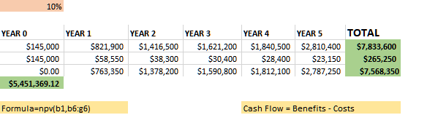

# ROI

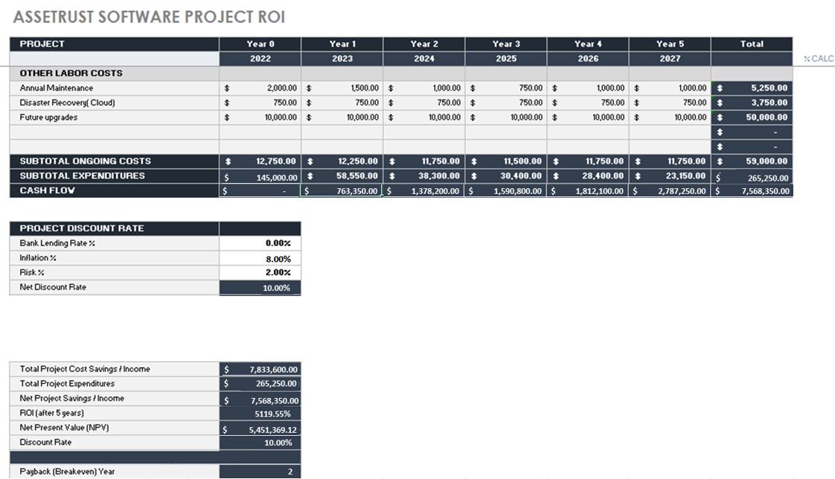

# User Stories

|  |  |
| --- | --- |
| **1** | As a security analyst, I want a prioritization feature that can provide a categorized list of asset values and severity of incidents. |
| **2** | As a team manager, I want collaboration tools such as an instant messaging system or message board that allow me to communicate with other users. |
| **3** | As a technician, I want a collective cloud-based database of past incidents that I can use to help prevent or contain present or future ones. |
| **4** | As a procurement manager, I want to be able to add assets in by type so that they are automatically categorized within the database. |
| **5** | As an end user, I want an advanced filtering feature that allows me to filter by different attributes such as life cycle stage, date of procurement, current condition, etc. so that managing specific assets is simpler. |
| **6** | As an incident responder, I want an alert feature that sends notice of an incident through SMS and e-mail so that the response time is quick, and the damage can be minimized. |
| **7** | As an asset manager, I want a feature that keeps track of an asset’s life cycle from beginning to end so that each asset can be attributed to their stage in the cycle. |
| **8** | As a user with impaired eyesight, I would like accessibility features that allow me to change the size of text to make using the software easier for me. |
| **9** | As an end user, I would like a Guide feature that provides tips & help on how to use each feature of the software so that I can learn more effectively. |
| **10** | As an asset manager, I would like the quantity of each type of asset to be tracked within a database so that I can manage them using accurate information. |
| **11** | As a user, I would like customization options that allow me to change aspects of the UI (User Interface) such as text color and menu positions so that I can create a personal workspace that lets me work effectively. |
| **12** | As a procurement manager, I want to be able to track the licenses of software assets so that I can renew licenses before they expire. |
| **13** | As a manager, I would like a dashboard that allows me to monitor and manage all network devices, servers and other assets all from one place to make management more effective and easier. |
| **14** | As a procurement manager, I want a discovery feature that automatically adds new assets based on configuration changes so that tracking assets is easier. |
| **15** | As a network manager, I want a capture feature that allows me to collect data from all devices on the network so that I have visibility on the connectivity of every device. |
| **16** | As a user, I want an auto-update feature that checks for updates on startup so that using the latest version of the software is seamless and easy. |
| **17** | As an asset manager, I would like to set different thresholds for assets that will trigger an alert via email so that I can stay on top and take prompt action. |
| **18** | As a user, I want keyboard shortcuts that let me use different functions of the software so that I can perform tasks quickly and more efficiently. |
| **19** | As a technician, I want to import and export asset lists in formats such as an excel sheet so that I can keep backups that I can revert to at any time. |
| **20** | As a manager, I want a mobile version of the software that can be accessed through a mobile web interface so that I can perform managerial duties while away from a workstation. |

# Schedule

# Budget Plan

To build the budget for ASSETRUST’s Software, the particulars were broken down into major sections including Labor, Software, Wrap Up, Reserves, and Maintenance. Within these sections are items that require budgeted amounts such as payrolls for the Project Manager and team members, Licensing and Development for Software, Testing and Marketing for Project Wrap Up, Reserves, and lastly Annual Maintenance and Disaster Recovery.

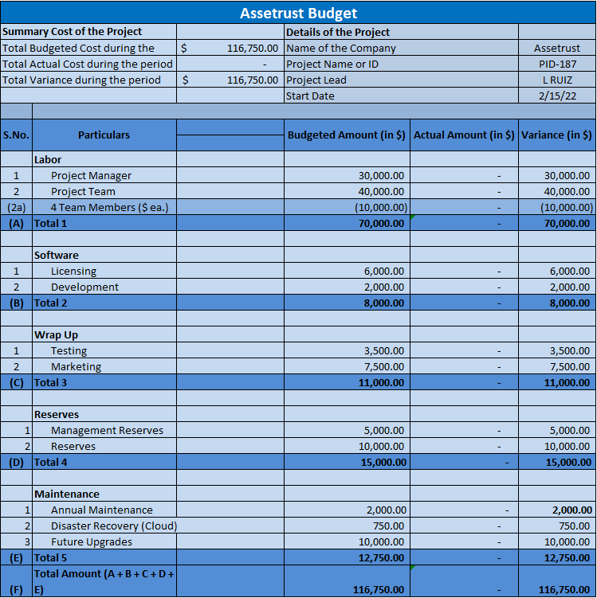

# ****Human Resources Plan****

The main component of the ASSETRUSTHR plan is human resources management. The human resources management plan will act as a tool to support management of human resource activities throughout the duration of ASSETRUST Software’s project lifecycle.

The scope of the human resources management plan includes:

* The roles and responsibilities of all team members involved directly with the project.
* The project’s organizational charts detail the assignment of tasks to team members.
* The staffing management plan, which outlines the staffing and hiring for the project, resource allocation, and work timelines.

The human resources management plan will be used by management to ensure that the right people are in the best positions to set the project up for success. The plan will also highlight how to address any identified skills gaps with the proper training.

## **Roles and Responsibilities**

As stated previously, it is important that the right people are in the right roles to ensure project success. It is critical that all team members understand their defined roles and responsibilities within the project for successful completion. The established roles for the project are listed below:

|  |  |  |  |
| --- | --- | --- | --- |
| Name | Role | Position | Contact Information |
| Luis Ruiz | Project Manager | Principal Software Engineer | Luisruiz@gwu.edu |
| Parsa Arfai | Solutions Lead | Senior Software Developer | Arfaip22@gwu.edu |
| Ian Davies | Architecture Lead | Software Architect | idavies@gwu.edu |
| Mercy Jalango | Business Lead | Software Support Manager | mjalango@gwu.edu |
| Marcos Vallejos | QA Lead | QA Engineer | marcosvallejos@gwu.edu |

**Project Manager (PM):** The project manager is the stakeholder responsible for the overall success of the ASSETRUST software. The PM is the one to authorize all work activities and is ultimately responsible for the acquisition of the human resources for the project. The PM must ensure that the quality standards and timelines for the project are met. Based on these evaluations, the PM creates reports to document the status of the project for other stakeholders. Finally, the PM will evaluate the work done by the project’s team members throughout the duration of the project and report on their work to their managers.

**Business Lead (BL):** The Business Lead is responsible for gathering all requirements of the ASSETRUST Software Project. As defined later, the BL will be responsible for the implementation of the in-house training regarding the software. The BL will also be the lead for the development of the eventual marketing campaign for the project.

**Solutions Lead (SL):** The Solutions Lead is responsible for all the development phases for the ASSETRUST Software. The SL is responsible for the creation of code that meets the defined requirements for the project. The SL will work with the Architecture Lead to ensure that the collaboration of the project’s design and development work is in harmony.

**Architecture Lead (AL):** The Architecture Lead handles the overall design and various releases of the ASSETRUST Software, including alpha and beta releases. The AL will work to work to ensure that the design of the software meets the defined requirements and expectations while staying within the scope of the project. The AL will work with the Solution Lead to help ensure that the development of the project follows the design.

**Quality Assurance Lead (QAL):** The Quality Assurance Lead handles the testing of the software during the alpha and beta releases. The QAL will work with the Solutions Lead to ensure that any bugs or issues that are caught can be fixed properly before the final release of the software. The QAL works with the Project Manager to ensure that quality expectations are met for the project.

**Business lead will conduct Training**

The Business Lead will handle the implementation of the training programs to train internal users on the features provided by the new software along with the upgrades compared to the software in use currently. This involves working with managers responsible for training and development within each department to coordinate training times and locations. This is a critical step for the successful implementation and effective use of the finalized software. The BL will work with the Project Manager to ensure that this training is completed company wide, and that ongoing support will be able to be provided.

## **Project Organizational Charts**

The ASSETRUST Gantt chart shows what team member is assigned to what task, and the timeline within they must complete that task. The organizational chart that would typically show the hierarchy of the project is straightforward, as each lead simply reports to the PM. It is important that any changes to responsibilities or tasks on the project be approved by the PM, and that the formal change control process is followed, to help keep the project organized.

Gantt Chart:

Team Organizational Chart:

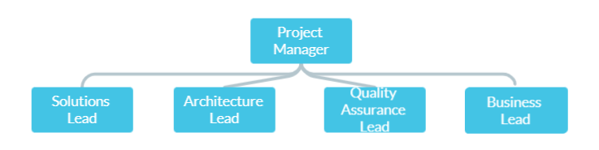

## **Staffing Management**

The core staff of the project is all internal, with no external hiring specifically for the project. The other staff that will be acquired within the project will be based on goodwill, as the budget is quite limited.

**Staff Acquisition:**

The staff composing the ASSETRUST project team will be internal. There will be no outsourcing or contracting performed for this project. The Project Manager will negotiate with the Solutions Lead and Architecture Lead to identify and assign resources in accordance with the project organizational structure. All resources must be approved by the 5 executives and the final sign-off is done by the Project manager.

**Resource Calendars:**

The responsibility assignment matrix will be used in combination with the PERT chart and WBS (Work Breakdown Structure) to show the corresponding roles and tasks along with the timelines given.

|  |  |  |  |  |  |  |  |  |  |  |  |  |
| --- | --- | --- | --- | --- | --- | --- | --- | --- | --- | --- | --- | --- |
|  | 1 | 2 | 3 | 4 | 5 | 6 | 7 | 8 | 9 | 10 | 11 | 12 |
| PM | RP | R |  |  |  |  |  |  |  |  |  | RP |
| SL |  |  | RP | RP |  |  |  | RP |  |  |  |  |
| AL |  | P |  |  | RP |  |  |  | RP |  |  |  |
| BL |  |  |  |  |  | RP |  |  |  | RP |  |  |
| QAL |  |  |  |  |  |  | RP |  |  |  | RP |  |

R = Responsible

P = Performing

## **Training:**

The User acceptance training and the UAT will be done at the Asset trust Office in Collaboration with Equinix data centers.

# Quality Management Plan

The Quality Management Plan will define the activities and processes to ensure that the ASSETRUST software meets the conformance to requirements and maintains fitness for use. The Quality Management Plan will provide: the quality standards ASSETRUST, LLC and ASSETRUST Software will adhere to, supplementary reference materials and documents to Quality Assurance, Audits, and Control, define the roles and responsibilities of stakeholders and the quality objectives and planning for ASSETRUST software.

## **Quality Standards**

ASSETRUST LLC will follow the guidelines and be certified to ISO quality standards to maintain quality control. The applicable standards are as follows:

ISO 9001: Quality Management Systems

ISO 27001: Information Security

ISO 12207: Software Life Cycle Processes

ISO 29119: Software Testing

## **Reference Material**

* FORM-001 Software Audits
* PLAN-007 Quality Assurance Plan
* PROC-004 Internal Auditing
* PROC-010 CAPA Reporting Procedure
* POLY-001 Quality Policy Statement
* CHCK-001 Quality Control Checklist

## **Quality Objectives**

The ASSETRUST Quality Management Plan will establish specific, measurable, achievable, realistic, and time-based quality control methods according to ISO 9001 standards. Quality objectives will be reviewed during the quarterly management review meetings for ASSETRUST Software where the goal will be to reduce non-conformance and defects observed in the Quality Audits. The Quality Objectives will then be communicated to the development team, project manager (or product owner) and the quality lead (or scrum master). The quality targets will include the detailed metrics, how they are measured and the acceptable level to still be considered satisfactory. Non-conformance of quality targets are documented in a Corrective and Prevention Action form to identify and eliminate the cause of problems and prevent recurrence of root causes.

|  |  |  |
| --- | --- | --- |
| Metric | Measurement | Acceptable Level |
| Defect Reports | Density of defects identified during software testing. | One defect per 1000 lines of code |
| Mean time to repair | The average time software engineers spend finding the cause of and solving the problem. | The mean time to repair must be under 5 hours. |
| Net Promotor Scores | Survey to identify customer satisfaction by surveying whether customers are satisfied with the software, will fuel growth, and refer others. If customer needs are being met, then customers should respond with a score of at least 7. | The Net Promotor Score should be maintained at over 50 to ensure there are more customers that are promoters. |
| Load Testing | The availability and performance of the system under projected user loads. | If 2,500 users are logged into the software application, then pages should load within 3-6 seconds. |
| Mean Time to Patch | The average time it takes to apply patches to critical vulnerabilities. | Software vulnerabilities patches should be pushed out within 90 days. |

## **Quality Roles and Responsibilities**

All team members of ASSETRUST Software understand their roles and responsibilities and play an essential role in quality management. All work will be completed at an acceptable level to meet POL-001 Quality Policy Standard:

“ASSETRUST, LLC is committed to providing a continual improvement of the quality management system and best practices by conforming with an effective application of international standard (ISO 9001) and all applicable local and regulatory requirements. A high standard of quality will be applied to all products and services to meet customer requirements and expectations. “

**Project Manager (PM):** The Project Manager is responsible for the implementation of the Quality Management Plan and ensuring that all work items that meet the definition of done conform with this plan. A healthy product backlog will also be maintained to ensure that high priority items are targeted and feedback by the development team and other stakeholders is being incorporated. Participate in management review meetings and conduct CAPA effectiveness checks.

**Business Lead (BL):** The Business Lead is responsible for the effective implementation of in-house training applicable to the ASSETRUST Software. The BL will also maintain and oversee the quality objectives being met at an acceptable level. Additionally, they will recommend tools and methodologies to best meet the acceptable level of quality objectives.

**Solutions Lead (SL):** The Solutions Lead will oversee the technical quality of code developed. They shall also request feedback throughout the development process and communicate with the QAL to resolve quality issues with the code.

**Architecture Lead (AL):** The Architecture Lead is responsible for ensuring that the design and releases of ASSETRUST Software are conducted to meet the expectations of ISO Standards and the Quality Management Plan.

**Quality Assurance Lead (QAL):** The Quality Assurance Lead will maintain the successful implementation of PLAN-007 Quality Assurance Plan to the ASSETRUST Software. The QAL will also oversee the successful implementation of the quality control approach of metrics that do not meet acceptable levels. They shall also follow up with corrective and preventive actions and ensure they are closed within the assigned timeframe. Any issues discovered by the QAL with the CAPAs, or areas of non-compliance will be escalated to the Project Manager.

## **Quality Planning**

ASSETRUST, LLC. is committed to conforming with the requirements set forth though the International Standards: ISO 9001, ISO 27001, ISO 12207, and ISO 29119. The processes and products of ASSETRUST Software will be verified and validated according to quality standards and to comply with the Quality Control Approach and Quality Assurance sections of the Quality Management Plan.

The Quality Control section records that all team members must be given CHCK-001 Quality Control Checklist to which will provide the requirements for all processes, products, and deliverables for ASSETRUST Software. The Quality Control Checklist will also provide the outline to ensure conformance with ISO 9001, ISO 27001, ISO 12207, and ISO 29119.

Non-conformance with the quality standards will be identified by the processes in the Quality Audit section of the Quality Management Plan. Corrective Action and Prevention Reports will be generated by an internal auditor and the findings will be reported during the quarterly management review meetings to the Project Manager and Quality Assurance Lead. The Project Manager and Quality Assurance Lead are responsible for overseeing and communicating with team members to close the CAPA reports in the given time frame.

## **Quality Control Approach**

ASSETRUST, LLC. is committed to providing quality control of all ASSETRUST software deliverables by verifying that metrics are within the acceptable level as stated in the quality objectives. In addition, quality control will also be maintained by quarterly quality audits by the internal auditor which will generate CAPAs and turn their audit findings to the Project Manager and Quality Assurance Lead. The team will be given CHCK-001 Quality Control Checklist to provide the guidelines that all processes, products and deliverables must meet according to quality standards. The tools and techniques that ASSETRUST, LLC. will utilize to the control the quality of ASSETRUST Software is:

* Cause and Effect Diagrams to identify the root cause issues and resolve the root problem.
* Histograms detect the frequency of density defect occurrences and ensure that the total acceptable level of defects is equal to or less than one defect per thousand lines of code.
* Pareto Charts show the largest number of customer complaints which can be prioritized to maximize customer satisfaction, create promoters, and brand ambassadors.

|  |  |  |
| --- | --- | --- |
| Metric | Acceptable Level | Quality Control Approach |
| Defect Reports | One defect per 1000 lines of code | Create a histogram for density defect reports to compile information at the end of the quarter. |
| Mean time to repair | The mean time to repair must be under 5 hours. | Create an incident escalation ticket to prioritize software repair. |
| Net Promotor Scores | The Net Promotor Score should be maintained at over 50 to ensure there are more customers that are promoters. | Reach out to all unsatisfied customers and create a pareto chart to identify problem areas to prioritize and improve quality. |
| Load Testing | If 2,500 users are logged into the software application, then pages should load within 3-6 seconds. | Create incident tickets whenever either real-time or test loads exceed 3-6 seconds. |
| Mean Time to Patch | Software vulnerabilities patches should be pushed out within 90 days. | When vulnerability patches are not patched, identify the severity of the vulnerability, and reprioritize all unpatched high severity vulnerabilities. |

## **Quality Assurance**

Quality Assurance will follow the company-wide PLAN-007 Quality Assurance Plan which identifies the controls set forth by ASSETRUST, LLC. to ensure products and services conform to the quality requirements set forth by the quality standards and the software quality objectives.

All ASSETRUST Stakeholders will be involved in identifying, assessing, responding, monitoring, and controlling project quality. Quality is a continuously improving process as such, the development team will ask the Project Manager for feedback during the development process and the project manager shall collaborate with the development team and quality engineers to test the product backlog items. The Quality Assurance Lead, Project Manager and Solutions Lead will be mandatory participants of spring planning meetings to ensure that all tasks are testable, identify gaps and that all tasks in the sprint scope are achievable. The Project Manger shall also take into the account the input of the development team based on facts and opinions before deciding when ASSETRUST will go-live.

## **Quality Audits**

ASSETRUST, LLC. maintains rigid measures to adhere to software compliance and will conduct annual company audits and quarterly audits for the ASSETRUST Software. The annual audit shall be conducted by an internal auditor which has completed the Lead Auditor training courses for the listed as listed in PROC-004 Internal Auditing. The company shall also undergo an annual third-party audit to ensure that the company is meeting the standard and legal criteria to maintain its business certifications.

The ASSETRUST Software shall be periodically audited by the IT Staff to ensure that the software is properly functioning, receives regular maintenance and shall communicate with clients to maintain proper software management. ASSETRUST is the flagship software for the company and shall also undergo quarterly internal audits by the internal auditors in conjunction with the IT Team. The quarterly audits shall also include licensing audits to observe that clients are purchasing the product in accordance with the license agreement.

Audit findings must be relevant to the software and to FORM-001 Software Audits, if there are issues within the findings there will be a corrective or preventive action report according to PROC-010 CAPA Reporting Procedure. The software audit findings and results will be reviewed at the end of each quarter during the quarterly management review meetings.

# Risk Management Plan

Planning for risks related to the project, as well as how to approach and address them alongside their consequences is an important part of proper project management. ASSETRUST’s Risk Management Plan serves as the documentation of activities related to risk, addressing important topics such as the methodology behind how risk management will be performed, roles and responsibilities as they relate to risk, the preparation of budget and schedule estimates for risk-related activities, the risk categories under consideration, the assessment of risk probabilities and impacts, and lastly the creation of any risk-related documentation. The risk management plan is an ever-evolving document that will undergo revisions and modifications as the environment surrounding the project and technology changes. As new threats and vulnerabilities lead to new risks being discovered, the risk register included with the documentation will be updated alongside the plan.

## **Methodology**

Risk Management will be performed on this project using the various plans set in place. While the project has its own plans, it is important to remember that the organization also has risk management policies in place at the corporate level. These higher-level risk management policies will be referenced to ensure that the project’s risk management strategy aligns with that of the organization. The most important plans regarding the response to risk related incidents are the contingency plans and the fallback plans. The contingency plans outline what actions to take in the event of a risk related incident. Preparation allows for an effective and swift response to incidents that may have potentially been harmful otherwise. The fallback plans are backup plans to the contingency plans, further building on the foundation of preparation. Tools such as the Risk Register and Top Ten Table will be used to keep track of the risks facing the project, and their severity. Utilizing a quantitative analysis, risks will be ranked within these tools based on impact and probability. Having this ranking system in place allows for effective risk mitigation strategies. On top of utilizing the plans and tools, the team will regularly participate in risk management activities to help identify risk. These activities include brainstorming sessions and interviews with both internal and external consultants.

## **Roles and Responsibilities**

Several roles and responsibilities must be assigned and specified to provide accountability. To begin with, there are responsibilities that should only be assigned to those with the authority to uphold them. When assigning the responsibility of ensuring the overall success of the Risk Management Plan, the Project Manager is the most appropriate role with the authority to complete the primary tasks necessary to accomplish this goal. These tasks include keeping track and managing all project issues related to risk management activities, ensuring all available information is accessible to the team, communicating issues and problems as they arise, and managing other to ensure they are fulfilling their responsibilities. Some of the individual responsibilities that can be given to the project team collectivity consist of activities such as identifying and assessing risks, identifying risk mitigation steps and reporting. Team members assigned to assessing risks must identify the probability and impact of each risk through the use of tools such as a threat matrix. Those assigned to identifying risk mitigation steps must describe steps that must be taken to reduce weaknesses as well as the overall impact of the risk. Last, the responsibility of reporting is comprised of sharing documentation with the manager who would then compile and create reports.

## **Budget and Schedule**

When assembling the budget for ASSETRUST’s software project, the project team identified critical sections which include labor costs, software costs including the licensing and development of the software, testing and marketing costs, reserves, and lastly annual maintenance and disaster recovery. The estimated costs for labor are $70,000, of which $30,000 is allocated to the project manager and $40,000 to the project team. A potential risk regarding labor costs could be team members working overtime because of the need to meet project deadlines. ASSETRUST would have to increase the budget to accommodate. The estimated costs for software licensing and development are $7,000. Software licensing will cost $6,000 and $2000 for the development. The testing costs are $3,500 while the marketing costs are $7,500, bringing the total to $11,000 for the wrap-up section. Additionally, the estimated costs for reserves are $15,000, of which $5,000 is separate for the management reserves and $10,000 for overall reserves. This amount will cover the risk of incidents occurring during the development phase. Lastly, the estimated costs for project maintenance, future upgrades, and disaster recovery will be $12,750. All these critical sections in the ASSETRUST budget carry the potential risk of going over the allocated amount for spending and resources for the project.

In addition to estimating the costs of the project, ASSETRUST has identified an estimated schedule for performing the critical tasks ranging from developing the actual software plan to the launch of the ASSETRUST product. Using a PERT chart, a chart to organize and schedule tasks and objectives for the project team to complete, the duration of the software project is 267 days (about 9 months). Developing the ASSETRUST software plan will take 20 days (about 3 weeks) to complete and 117 days (about 4 months) for software developers to create code for the product. There is a risk that the program developers may finish creating the code late due to employees calling off work, which would delay the code creation task to 137 days (about 4 and a half months). This risk generates another risk for the release of the Alpha version being 176 days (about 6 months) later and further the testing of the Alpha version to 199 days (about 6 and a half months). Lastly, the delayed release of the beta version will be 243 days (about 8 months), in which the beta version will proceed to the quality assurance test. A risk in this task could be the software not being compliant with the quality requirements as specified by the Quality Assurance lead. All the delays in tasks and the alteration of the quality of the product will lead to missing the deadline to launch the ASSETRUST software, which can hinder relationships with customers, partners, and stakeholders.

## **Risk Categories**

When defining the broad risk categories, there will be potential risk in all these categories for ASSETRUST. There is a market risk associated with the new software, as it will provide a new service. There is a risk that inexperienced users do not adopt the software as envisioned, or that a competitor comes out with a more viable solution. There is less of a financial risk, as the organization is capable of funding the project, and estimates show a viable ROI. If the project fails entirely, it will be very costly, but it will not put the company out of business. The technology risk associated with ASSETRUST is there, but through proper planning it has been determined that the project is technically feasible based on the assembled team. The technology used to implement ASSETRUST is not bleeding edge, it is more about the final functions of the software rather than the actual technology used to implement these functions. Because of this, the technology risk associated with the project is low. People risk within the company is also relatively low, as the team assembled to handle the project is fully qualified to complete the project successfully. There is a project champion and senior management has bought into the project in terms of support. The final risk category to be concerned with is the structure and process risks associated with implementing ASSETRUST. The use of the product could potentially change the day-to-day operations for certain employees significantly, meaning that training must be comprehensive. This also means that daily users of ASSETRUST must be satisfied with the result.

After analyzing the various risks associated with the creation of ASSETRUST, a basic risk breakdown structure has been created to highlight the main risk areas for the project.

## **Risk Probability and Impact**

The ASSETRUST Risk Register will be used to outline the probabilities and impacts of the various risks that the project potentially faces. The Risk Register also highlights the potential triggers, root causes, and potential responses for each risk. The risks are given assessments regarding potential and impact, allowing the risks to be ranked based on severity. Based on these rankings, it is clearly defined which risks have the potential to cause the most harm. The probability and impact matrix that visually shows the impact of various risks will be developed directly using the rankings from the Risk Register. All these tools allow for the successful analysis of potential risk, allowing for the creation of an effective risk management plan.

## **Tracking**

The project will track risk management activities in several diverse ways. It is important that each member of the team is aware of all necessary documentation that must be completed. The Risk Register will be a live document that the team will reference and continue to complete as risks arise. The change request log will be used to keep track of changes to the project and when they occurred. An accurate change request log is critical to being able to stay aware of potential risks to the project. The issue log will be used to document any issues or incidents that arise. A lessons-learned register will be used to keep track of any growth opportunities that occur during the project. This could include areas that have room for improvement in the future as well as processes that worked well. This document will be available to the entire team to complete as needed. While this is most important to review at the conclusion of the project, the lessons-learned register should be filled in throughout the duration of the project. This will ensure that nothing is forgotten and the information within the register is accurate.

While the Project Manager is responsible for the success of the Risk Management Plan, the Quality Assurance Lead will be responsible for auditing the risk management processes and techniques throughout the duration of the project. The Quality Assurance Lead will also be responsible for maintaining the Top Ten Risk Item Tracking Table. This table will be used to outline the top 10 risks that the project faces. This table will be updated regularly for an accurate snapshot of the status of risks facing the project. The Top Ten Table will also allow for accurate tracking of the effectiveness of risk mitigation strategies. Mitigation strategies can be shown to be successful when a risk is removed from the table after implementation.

## **Risk Documentation**

Several different reports and plans make up the documentation used to keep track of all risk management activities related to the project. The contingency plan defines what actions will be taken if an incident occurs. The fallback plan takes this one step further by defining what will be done if attempts to reduce risk fail. Contingency reserves and management reserves have been budgeted to proactively prepare for the consequences of incidents. Utilizing the defined actions in the risk management plans creates a structured process for the project’s response to risk. The project will also utilize change management logs to help reduce the amount of risk when changes occur.

**Risk Register**



# Project Closeout

1. **Project Information**

**Project Name:** ASSETRUST Software

**Project Description:** ASSETRUST Software strives resolve high severity incidents through the usage of a proprietary AI that can make decisions based on asset values as an effect it shall also provide more interactivity in the Asset Lifecycle Management in data centers by being able to better monitor and manage devices.

**Project Manager:** Luis Ruiz

**Solutions Lead:** Parsa Arfai

**Architecture Lead:** Ian Davies

**Business Lead:** Mercy Jalango

**Quality Assurance Lead:** Marcos Vallejos

**Project Start Date:** 02/15/2022 **Actual Start:** 02/14/2022 **Variance:** 0

**Project Finish Date:** 11/25/2022 **Actual Finish:** 11/09/2022 **Variance:** 16

**Baseline Budget:** $150,000.00 **Actual Budget:** $116,700.00 **Variance:** $33,300.00

1. **Deliverable Sign-off**

|  |  |  |  |  |  |
| --- | --- | --- | --- | --- | --- |
| **Deliverable** | **Acceptance Criteria** | **Project Manager** | **Date** | **Comments** | **Project Manager Approval** |
| Website Launch | The website is interactive and has interactive videos to give more information about our company and the ASSETRUST Software. It also has the pricing options that will be available at launch. | Luis Ruiz | April 26, 2022 | There was an opportunity to take longer on the website but enhance client interactivity. | **Luis Ruiz** |
| Alpha Version Release | The ASSETRUST Alpha Version must have met all the features, design and functionality requirements as outlined in the software plan. It must also be free from major bugs and must be testable. | Luis Ruiz | August 05, 2022 | The alpha version was able to be released a couple of days earlier due to major bugs being found early in the testing phase. | **Luis Ruiz** |
| Beta Version Release | The ASSETRUST Beta version must resolve all the issues discovered in the alpha version test and should have no flaws that impede the software’s functionality. This release must be in a stable state. | Luis Ruiz | October 13, 2022 | The Beta version has minor flaws to improve upon and could focus on more design issues and was released earlier than expected. | **Luis Ruiz** |
| ASSETRUST Launch | Quality and load testing has been performed to ensure that ASSETRUST will have no functionality issues at the time of launch. Minor bugs that impact quality of life must also be resolved. | Luis Ruiz | November 09, 2022 | Due to minor bugs being fixed in the Beta Version, only quality of life improvement and load testing had to be performed. Released substantially earlier than expected. | **Luis Ruiz** |

1. **Management Input**

The ASSETRUST Software met all its goals on time and finished under budget by 22%. On its release date it also exceeded all market expectations due to the marketing team and is now seeing widespread implementation all AWS data centers and many other data center providers in the Northern Virginia area and is now looking at national expansion. While the project was a major success the team did face major communication issues throughout the project. The Architecture Lead took personal responsibility and initiative to prevent communication from creating roadblocks or postponing deadlines.

1. **Contract Closure**

All software licenses were purchased during the software plan development and Business Lead successfully conducted negotiations with Adobe, QuickBooks, Microsoft Office, and Oracle Support. Adobe and Microsoft 365 both have an annual license and QuickBooks has a 3-year long license. Once the marketing campaign began, contract negotiations began with Salesforce and Hootsuite and were completed within 2 weeks of the start. The salesforce and Hootsuite licensing will also be paid annually. The SEO Expert contract was paid in full at the end of their contract.

1. **Lesson Learned**

There were no setbacks in the project due to the Architecture Lead’s active involvement and design of the software making sure that software configurations met their success criteria. The biggest issue of the development of the ASSETRUST Software was the lack of communication. The preferred method of communication was email and collaborative tools were not fully used which made communication between team members much more difficult to discuss active ongoing issues which needed quick response times. To improve communication, the usage of collaborative tools will become integrated to the company and will be a mandatory requirement for all future projects.

# Conclusion

ASSETRUST is a software tool that will offer effective asset management powered by AI, providing greater network visibility, security, efficient resource management, and enhanced connectivity.

ASSETRUST software’s main goal is to ensure optimum operational performance within data centers by providing enhanced interoperability, network and system integration and resource sharing. Employing the use of AI intelligence will provide in-depth network analysis on a granular level, with the ability to identify and predict network anomalies and network glitches in real time and provide alerts to mitigate and prevent downtime. The ASSETRUST software boasts a lightweight sandbox to ensure that the system software is not compromised. Overall, ASSETRUST will enhance data center performance, eliminate down time, ensure proper management of resources and reallocation of resources where they are most needed, and boost profitability of data centers.

# ​REFERENCES

Malone, Katie. 2021. *https://www.ciodive.com.* September 21. Accessed April 17th, 2022. https://www.ciodive.com/news/uptime-institute-data-center-downtime .

templates, www.gantt chart. 2022. *ww. Gantt charts.* April 5. Accessed April 5, 2022. www. Gantt Chart.com.

​Zenlayer. 2018. *https://www.zenlayer.com/blog/data-center-downtime/.* January 17. Accessed APRIL 2022. https://www.zenlayer.com/blog/data-center-downtime/.